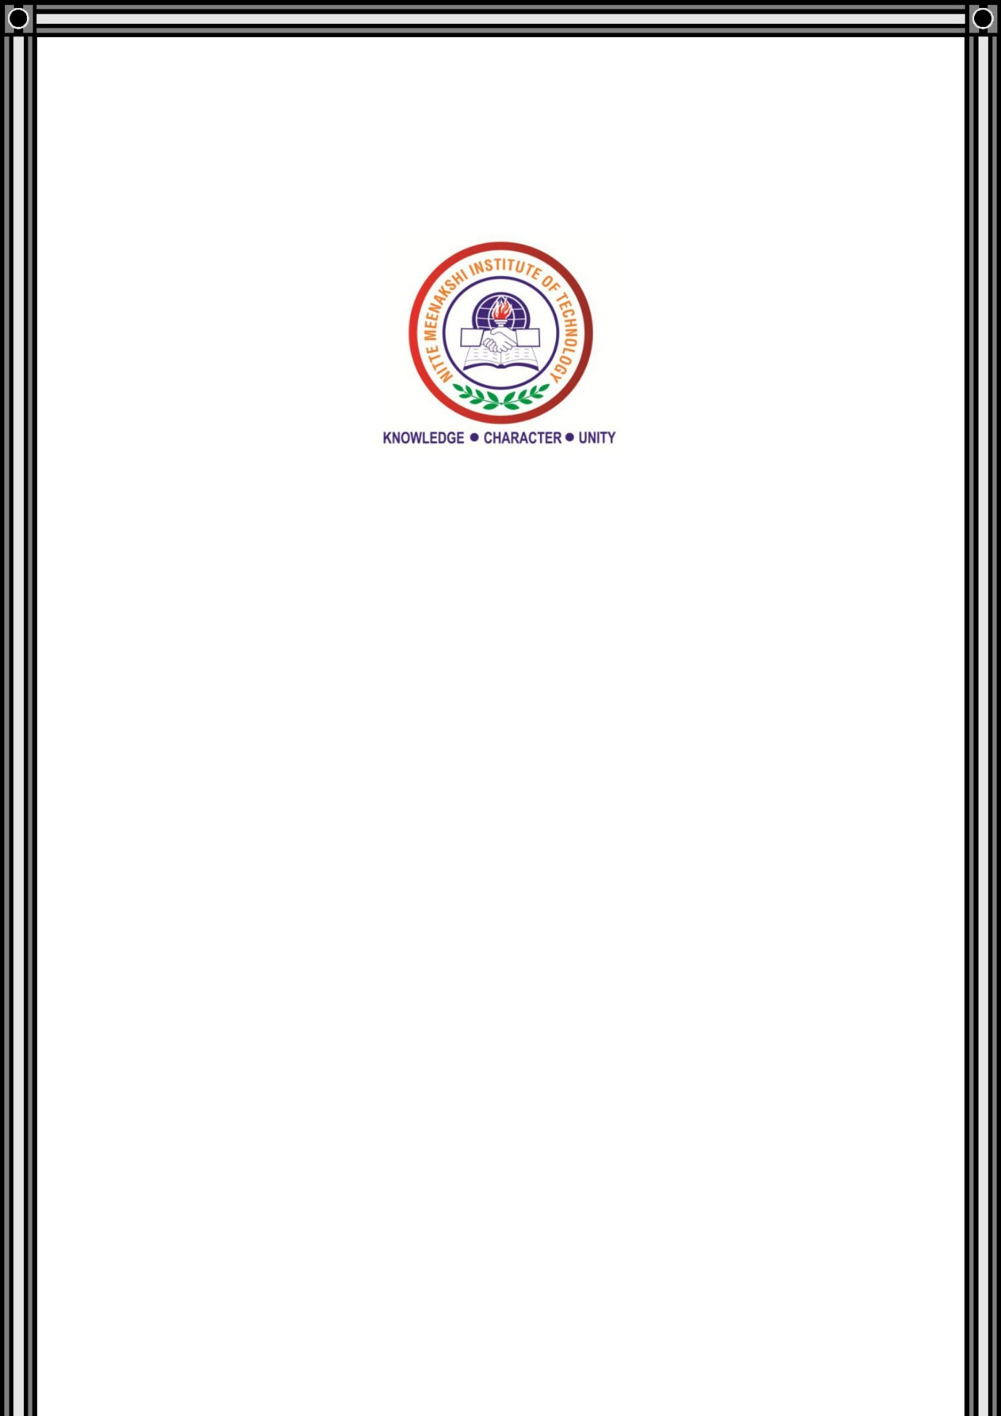**NITTE MEENAKSHI INSTITUTE OF TECHNOLOGY**

(A Unit of Nitte Education Trust(R), Mangalore)

(AN AUTONOMOUS INSTITUTION AFFILIATED TO VISVESVARAYA TECHNOLOGICAL UNIVERSITY, BELGAUM)

ACCREDITED BY NATIONAL BOARD OF ACCREDITATION (AICITE), NEW DELHI

Govindapura, Gollahalli, P.B. No. 6429, Yelahanka, Bangalore 560-064, Karnataka, India

**A seminar Report**

**On**

**H225M**

***Submitted in partial fulfilment for the Subject***

**Helicopter theory**

**Submitted by**

**Yashwanth Aradhya H R**

(1NT15ME201)

VII Semester 'C' Section Department

of Mechanical Engineering

NMIT, Bengaluru.

**Faculty Co-ordinator**

**MR. SUTHAN**

Assistant Professor

Department of Aeronautical Engineering

NMIT, Bengaluru.

**2018-19**

